IW-16
YEAR 9 SCIENCE (MODIFIED)
BIOLOGICAL SCIENCES
TEST - BODY SYSTEMS

NAME: CLASS: Mark: 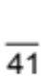

Multiple Choice Write the answer to each question in the appropriate box at right.
QUESTION | ANSWER
1
2
3
4
5
6
7
8
9
10
11
12
13
14
15
16
17

1. Which of the following lists contain only examples of mechanical
digestion?

(a) Chewing in the mouth and the churning by stomach muscles.
(b) Chewing in the mouth, chemical break down of proteins.
(c) Churning by the stomach muscles and chemical break down of
proteins.
(d) Chemical break down of proteins is the only example.

2 . Where is the digested food absorbed into your blood?

(a) Mouth.
(b) Large intestine.
(c) Small intestine.
(d) Stomach.

3. What are the main functions of the stomach?

(a) To store food so that you can use it when you are hungry.
(b) To break food down into a thick soupy liquid and to begin protein digestion.
(c) To make enzymes to digest fats, proteins and carbohydrates.
(d) To digest all the food you eat so it can be absorbed in the small intestine.

4. Absorption of water in the digestive system occurs in which of the following organs?

(a) The stomach.
(b) Large intestine.
(c) Liver.
(d) Anus.

5. When urine leaves the bladder it:

(a) is taken to the kidney.
(b) moves through the ureter.
(c) moves through the urethra.
(d) is taken to the liver.

6. What is the purpose of digesting your food?

(a) So that the muscles in your oesophagus can squeeze the pieces down to your stomach.
(b) So that you can break it into pieces small enough to swallow.
(c) To break it into molecules small enough to be absorbed into your blood.
(d) The food keeps your stomach and intestines alive by giving them energy.

7. A number of nutrients provide our bodies with energy. The main source of energy is:

(a) vitamins.
(b) protein.
(c) lipids.
(d) carbohydrates.

8. Two nutrient groups are required in very small amounts for healthy growth. They are:

(a) vitamins and carbohydrates.
(b) minerals and proteins.
(c) carbohydrates and proteins.
(d) vitamins and minerals.

9. What do we call the heart chambers that pump blood out of the heart into the arteries?

(a) Left and right ventricles.
(b) Left ventricle and left atrium.
(c) Right atrium and right ventricle.
(d) Left atrium and right atrium.

10. According to the CSIRO's recommendations for healthy eating, people need to consume 3 serves a day of:
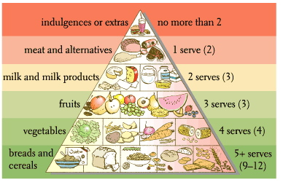

(a) meat and alternatives.
(b) bread and cereals.
(c) fruit.
(d) indulgences or extras.

11. What is the name of the group that includes the nutrients starch and sugar?

(a) Vitamins.
(b) Lipids.
(c) Fats.
(d) Carbohydrates.

12. The lungs move air in by muscular movements of the rib cage and the _____.

(a) trachea
(b) ribs
(c) alveoli
(d) diaphragm

13. _____ carry blood away from the heart.

(a) Arteries
(b) Bronchioles
(c) Veins
(d) Venules

14. The millions of tiny air sacs in your lungs are called _____.

(a) capillaries
(b) bronchioles
(c) alveoli
(d) bronchi

15. The smallest blood vessels in your body are called _____.

(a) capillaries
(b) venules
(c) arteries
(d) arterioles

16. Backflow of blood back into the heart is prevented by _____, which allow blood to flow only one way.

(a) valves
(b) arteries
(c) atria
(d) veins

17. The chamber of the heart that has the thickest wall is the _____.

(a) right atrium
(b) left atrium
(c) left ventricle
(d) right ventricle

Short Answer Write the answer to the questions in the spaces provided.

1. Write the name of the parts shown in the following diagram of the digestive system. Choose from the following list. (6 marks)
liver oesophagus salivary glands anus small intestine mouth
large intestine gall bladder appendix pancreas stomach
PART | NAME
A
B
C
D
E
F
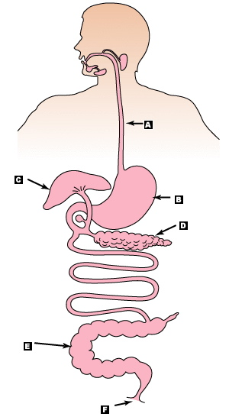

2. There are three enzymes that target the three major food groups. Complete the following table. Choose from the following list. (3 marks)

water vitamins proteins minerals fats/oils fibre carbohydrates

NAME OF ENZYME | TARGET FOOD GROUP
amylase
protease
lipase

3. Label the parts of the heart marked A to F. Choose from the following list. (6 marks)

left atrium left ventricle right atrium right ventricle valve pulmonary artery
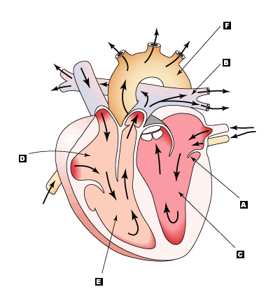
pulmonary vein aorta vena cava

A
B
C
D
E
F

4. Use the following diagram of the human excretory system to help complete the table below. Choose from the following list. (4 marks)

lung kidney heart bladder urethra liver ureter pancreas renal artery
renal vein
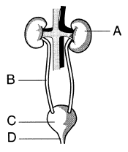
LETTER | NAME OF STRUCTURE
A
B
C
D

5. (a) Write a word equation for respiration. Use the following terms. (2 marks)
energy oxygen carbon dioxide water food

+  +

+

(b) What are the three waste products of respiration? (3 marks)

u w c d

